Guillén, Jorge [Jorge Guillén y Álvarez] (1893 - 1984)

Spanish poet, literary critic, and scholar, Jorge Guillén belongs to the Generation of ’27, a group of Spanish poets – which included Federico García Lorca, Rafael Alberti, Pedro Salinas, and others – that emerged in the cultural scene of 1927 beginning with the tribute to Luis Góngora that took place that year in the Ateneo of Seville for the third centenary of his death. Guillén, who was born in Valladolid, Spain, is regarded as one of the greatest Spanish poets of the twentieth century.

He attended school in Spain, Switzerland, and Germany, and earned a doctorate from the University of Madrid in 1924. During his career, he lectured at the Sorbonne, Oxford, the universities of Murcia, Seville, Puerto Rico, McGill (Montreal), Harvard, Middlebury College, and Wellesley College. He taught and wrote poetry in the United States for over twenty years, and was a professor at Wellesley until his retirement in 1957. He began writing poetry when he was sixteen years old, gaining recognition very early with his first poems, but he left Spain in 1938 after the Generalissimo Francisco Franco took power.

His uniqueness resides in having remained faithful to the ideal of pure poetry, offering a peaceful and optimistic vision of the world, which is the antithesis of the cosmological pessimism of Nobel laureate Vicente Aleixandre and other existential poets of the day. Guillén proclaimed once that “the world is well made”. However, in a post Spanish civil war era his statement earned him a certain enmity among the existential and social poets who suffered from the harsh consequences of the war. Guillén would correct himself later, announcing, “the world of men is wrong”.

Guillén´s main poetic work is gathered under the title *Aire nuestro* (1968) that consists of three of his great books: *Cántico* (1928), *Clamor*, published in three volumes (1957, 1960, and 1963), and *Homenaje* (1967). Later he published *...Y otros poemas* (1973) and *Final* (1982). He is a poet of short verse and the hendecasyllabic, searching for the maxim and concision. His elaborated poetic language is the result of a rigorous process of selection of words supressing accessories in order to communicate the core idea or essential feeling. Capable of both formal sophistication and meditative openness, Gillén´s poetic work is characterised by a jubilant affirmation of being and plenitude, the passing of time that invites one to enjoy life, and fate and chaos that cause insecurity and suffering. Hence, his poetry is difficult not because of its ornaments, but for its condensation and density: each sentence, each word tries to undress the essence of what the poet presents us. This attention to the essential is reflected by some features of his style as the abundance of nouns, often without an article, and nominal phrases, without verbs, because the names reflect the essence of things, not its existence, as the verb.

Guillén, often compared with Elytis, Aleixandre, and Borges, received a series of awards: the Award of Merit from the American Academy of Arts and Letters, the San Luca Prize, the Miguel de Cervantes Prize, the Alfonso Reyes Prize, and the Ollin Yolitzli Prize. He returned to Spain in 1977 two years after Franco's death, and he died in 1984 in Malaga.

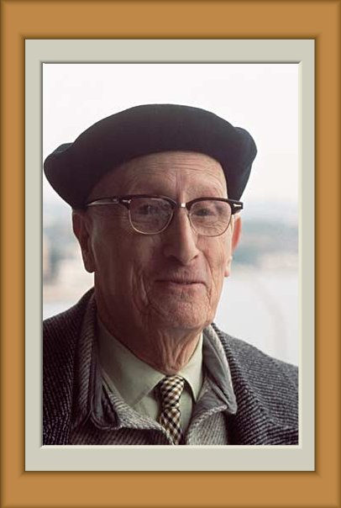

**Photo:** www.artepoetica.net

**Reference and Further Readings**:

Alberti, Rafael (1976). *The Lost Grove*. Berkeley and Los Angeles: University of California Press.

Connell, Geoffrey (1977). *Spanish Poetry of the Grupo poetico de 1927*. Oxford: Pergamon Press.

Morris, C. (1969). *A Generation of Spanish Poets 1920-1936*. Cambridge.

Gibson, Ian (1989). *Federico Garcia Lorca*. London: Faber and Faber.

Havard, Robert (1986). *Cantico - Critical Guides to Spanish Texts*. London: Grant & Cutler.

Guillen, Jorge (1961). *Language and Poetry*. Cambridge, Mass.: Harvard University Press.

**Paratextual Materials**:

Poets.org: <http://www.poets.org/poet.php/prmPID/697>

*Jorge Guillén. Biografía*: <http://www.cervantes.es/bibliotecas_documentacion_espanol/biografias/milan_jorge_guillen.htm>